We will be using Python 3.0 onwards for the upskilling sessions. The following instructions apply to a clean slate installation (i.e. you dont have Python pre-installed or an older version) . If you have an older version then better to uninstall that and install Python 3.6.3 from scratch.

1. On your AWS or local machine ,open your browser and download the Python 3.6.3 installer for Windows 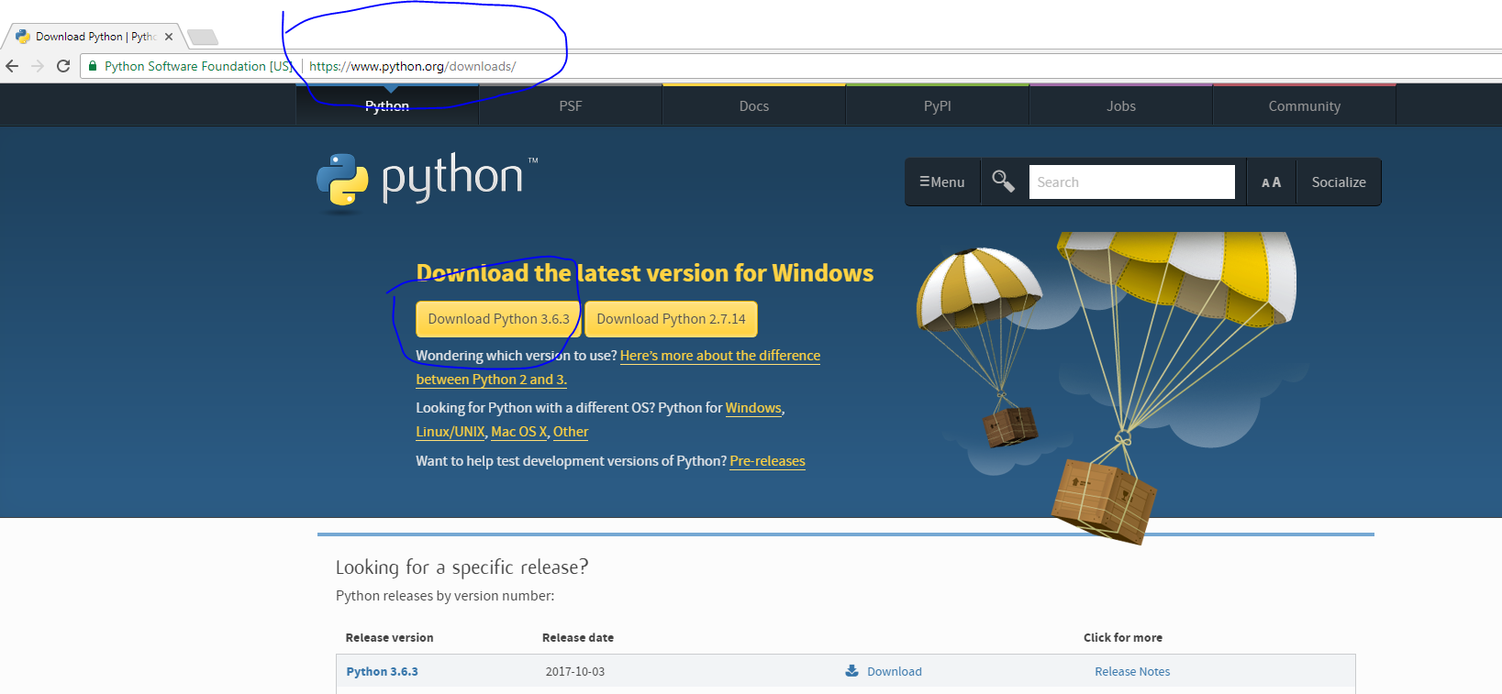
2. Run the installer and ENSURE that both the checkboxes for (install for all users and add to path is checked ) . Adding to Path is critical to ensure that you can run the Python interpreter from command line just by typing “Python” ( more on that bit later) . For all users is required in case you are a non admin on the machine. On checking the checkboxes proceed to “Install now”

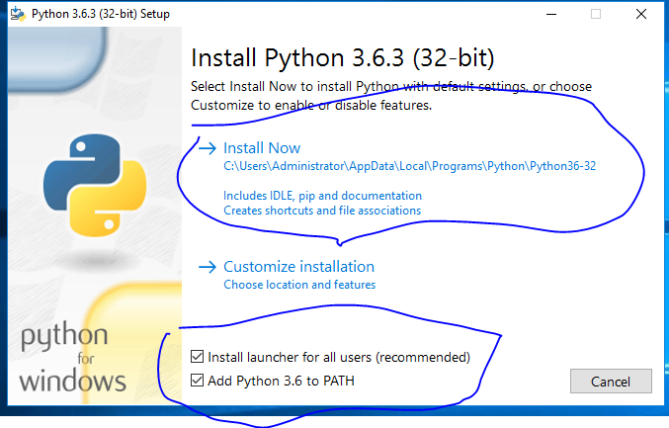

3.Once the installer has finished installing, we need to test for a succesfull install. For that goto command prompt and type “Python” , the installed Python version should be returned plus the “>>>” symbol indicating that you have entered the Python interpreter ( as below)

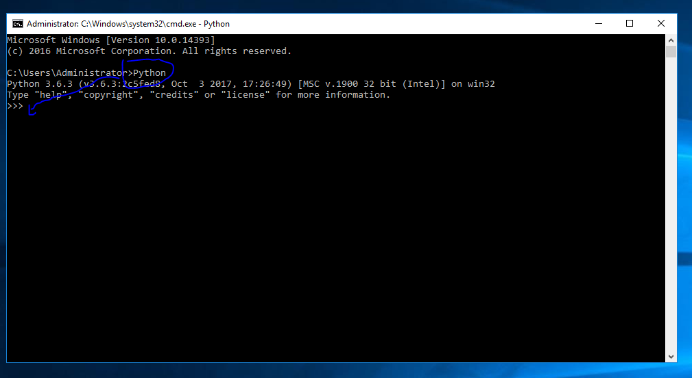

Troubleshooting …

In case the Python command in previous step does not run , a typical reason is that Python is not added to Path .

Couple of options

1. Uninstall Python and re-install with the “add to path” option ticked in the installer
2. Dont uninstall and add Python exe’s location to path (as below)

Goto Control panel → System and security → System → advanced setting → enviornment variables

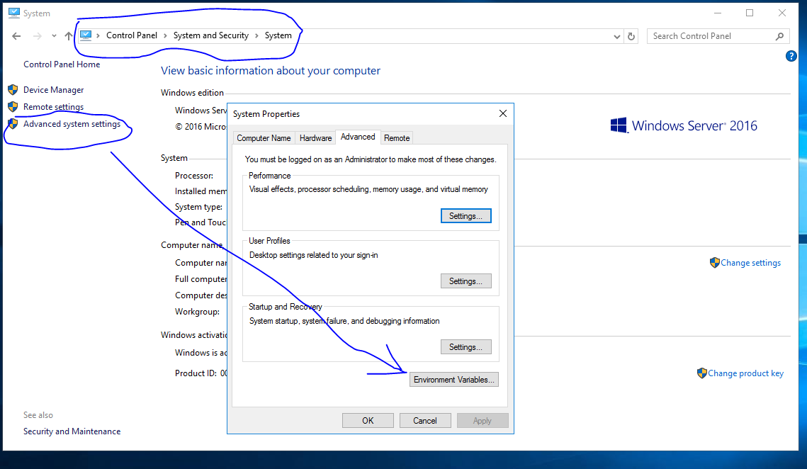

On the next screen , click Edit to choose to edit the “Path” variable

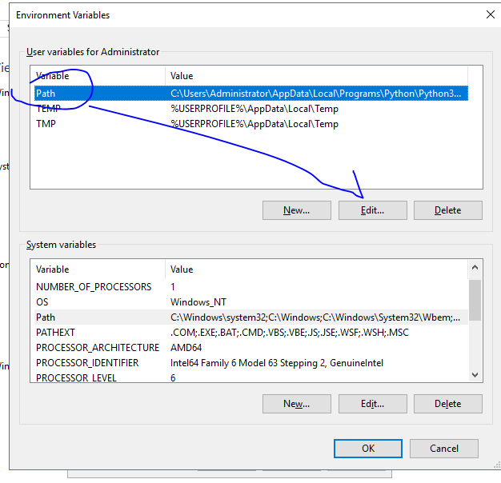

There should be two Python related entries here

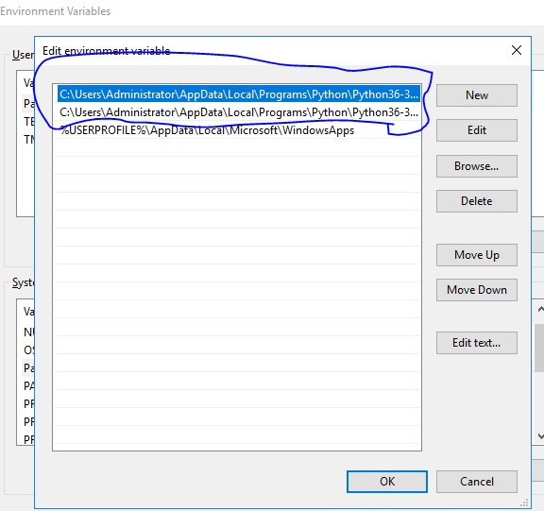

If not ..add the following and retry Python command from the command prompt

Assuming you installed Python ( from the installer) in the default location . Username is a placeholder and needs to be the user of the account you are currently logged into.

C:\Users\<username...>\AppData\Local\Programs\Python\Python36-32\Scripts\

C:\Users\<username....>\AppData\Local\Programs\Python\Python36-32\